^{(3fuFi6iiiG.1} J
<t(qTm-."I c'fcqt
_{1-dd{rr,} ^{q.} {r re. aooe
I r! €<i{.€n .ne_ a( €qnrF _{6.;q} ^{qi{r} 6F!1? 6lntE ft6"F _{e} ^{(aiF} li-taI
^{qin} FeE !i.m
_{a{qr'r} ^{qfi} i*s <d
^{€nlr'l *. f,f"r} _{"t<,} mr
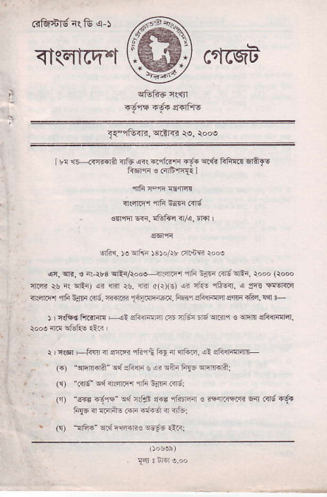
drcl. r! vri1., )3r./rr 61{-8 ro,o
^{q,} _{sr?, s} ^{;i} _{$s} ^{qFn/iooH[drfr j} _{4tr laF Fd} ^{q,-.} _{r,o'} (ioo! ^{qri.ri} * { ^{qlrJ} !? 4R r!. rFr _{nlr)(s)} !i -i- ^{!tq. !} st'. s!-RFr _{4ir@r} ^{q6 -rF 16- ffiB} _{fE} retr. iijr si14tsxd sm 4tf,i. $r +
) i r{Fin ftR:m +- !i]448 r ltr;- _{t.;} ^{q.r} | € ^{qm} aiftFnFr
ntq F +m 1?ffi.nni i;ra 1lF.,F. rl di14@trr
({) "qFFdi']" ed oiilri e r? ini frfs FFft:
₍₁ ^{'ad"} s'.1 ftlmi .nn :nF Fn;i
(r) "arr _{+?+} ^{qd} i{r} !?r rnrml . F{ffi4i s! ias -.6. ,i{d r FF+, FF 6i., n 1i3i
_{(r)} ^{'!i45" q.!} E'@E€ ^{-'u!o} r-nl
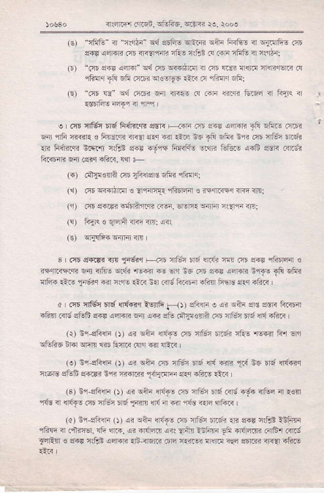
(E) ^{"?ftE"} _{I} ^{_n$ZF q,{} stii- 4FF o?n F!11- m ^{!.n!Fo} m $iF siffi 6 TrTqcn 1ai rflt f4.4i,rFfr a ftriq:
_{o)} "ce snd !ffi" trd ft wbEn n _{m} ¹⁶ r@ r46.E1F c ^{.fni} _{li!} ^{1fi} _{?lDi} ^{qcor-ls} rt4 r ,rar rtu:
_{lE)} ^{'m} E @i _{mri F} ^{lre} 4 FF @.qi tu/F .r ias n 5a6.''-"''-.
^{q} 4Fr Endl c F@E ma !.r @ riF ^{1q-} _{iir} biE nn.iD i6i rr.liE * F,inz-ai ;mt rilJz a+r +-!,t'r ffiE 4R ffin EiF s?ri .rtr; ti]@R F.sq lim- !a +
₍₄₎ ^{qt]!€qlil m} _{1ts{} 5c s6r4 !,?4.:
(1) 6 @umr3 _{?r.rtrlr} lJrF@
(i) .6 efri oifa'll.F .@, ^{qr&} si! {?.n d;
_{l!)} ^{rTic a} _{:j6a,i <@ iirl} (?r
_{i!)} ^{q$1;4} T4rFi ir?
3 _{.nE} .F.!'r ^{rri} _{f<ir} ^{q.i5} iiiin ri ?r|ii a1 rnD lir rla61r;r € r{qr4ril ri4 _{nirlo} q.<r ^{'tr-ir} @ e'r t6 ft s?r ^{{{iri ica6} _{lft} 6fii ^{'{t{+ €fi} _{1-,3r.r} .il ren _{riF} i{ fit iniE;r ?im hnE- eq itui
d , m llin nd n6Gc ^{W} _{a {r)} {r4n o ai rni !'e ff i?r.@ ifiT _{m;} ^{qffi} {.? a@F ra i?i drj rd1.!c+il .;r _{fJ?} ^{yli} r{ ?F i
(!l 3nslin (, ii oni 4n.?! rir 4t; rdE _{iiro} ^{'E{ir} li. lir _{!ffi5 n6} ^{qrF} cr i1irF .ir' Fir rllF
(r) nr.sh{F (t {r ^{!+4} m T ; n; rq ^{6ir.} _{T,i} }6 'r.; r,t€q ^{nr6ts siEE eiiEi srr i-44?,<} _{1n{r@} aFl itui €F
^{'3} r ct-. .' r. ^{inea} _{n--, bJ..-s.+a 1} ^{4t} \t ^{,risa} !r'F- m nf;nrd1@ rd? @ f{! ili :ir.ra r
(d) iq snn ()) di !tu <6.- air nfn rfd lR e-E ?lF!e -nf'F rfiE 4 a4nd. _{rli} ^{qF- €i F6@ r<r} ?tu l-im _{lfr} .Fi,ffi 16.r m; _{FF:n} ! ${6 rfJt !'n€F rf ftrin _{FE} ^{'i?rm} n @ .F ^{ffi @!r} "i?.5
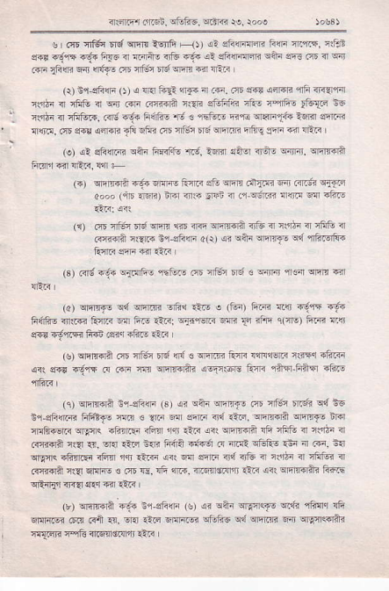
_{Tff !Fd.iEidi-} ^{fr.} .o {,'
! | (rr irffi nd ^{cm} .€nfi F{ !i eF rdqR ftrF 4P.Ls. n,ftr s4r ^{4!* -.1" ftaE { @rni 4tu} _{1t4} {i sli4.ffi ean ft m 4 r riF _{iftcF} e:R <6itu m n]i;r tt u1nfl @ nr11i
(r) Gr si.r<F- (J) ! nRI _{fi-ri} a&i ^{nr} trn. 7t !3F aiFF nrfr.,4?lqiir _{?.bn i ifft n} ^{qqr} r.F .ffin nqi ^{srffiir4 l&! flrF-} _{tfETi} ns _{n:dr} ^{q} rl:qlv3. .{6 _{n'$ hifiE} ^{'i} 3 .-tu- E _{ft} ^{qlFF1.i.} ltirir ffi _{lKirq. m} ^{qqH qi+ri} _{Jtu} ^{3f&} rn5 nrtu: 5F _{wm} ^{qtug} _{$"F ?d} ^{q,lt} L (o) _{!l} qft<r_.n ^{qnF} ffi4-'a;. anir rircr rn- -4rFr. rmrflil
_{FJ} oFm-n F- m EnF aft rm d-?ni _{6 err;i} q-r.a6 d.,' (n6 aFlr) tF riri. EFin n .. s;m i@ F{ iiTr.
^{(i)} .ir ai,:r 6r; rm _{?d dn} ^{qFRF;} .ri6 nr ist nr tfltu ir .'Fw+ illrF t1-oiirF _{{ir) ri} qtu q,iuq1 ^{qd} nF..i's _{E4ri} 3:f 44 r.r.r
(3) .ild r.r4 Frlrfi- enfz- m .f;n t 3r € T"rFr n .4 _{cEm} qr
frifi- ftr+r r?>ri? o fii,- r-:.ii _{EinlrF} . ¹⁴ _{F} iFF 1rft) fi..i 46 _{eFr} ^{q'e.} ffi ffi .e1q ii.4e .-ri
_{(s)} ^{qcrFa} ot tli<i _{tF {E' e} ^{llr'm} _{tua{} {.81€i.7 nrrq.ifl.- a( 3r. i:ef5 6 @F _{d} ^{q6PF6?} !-Frft ft'.rr rr.l':ir t'nq <Er
_{(c)} ^{qEfidri} :'i d"rd (sr _{!i} ^{qh qF.€} m _{.i=i t.!tu} ^{qd} no $isEffi hii-.ft :m . _{.fr} lrr dir6 .rd _{i-rq.} ^{qFEFA qEr.fs} ;Rr _{rflFi€sni} ^{qlF4<} _{?tu[!i i.!i} ^{'qr} r{6 a?r wmft !fi nffi i ii'l2i ir GrriFri !q _{.4,} sM.l,i .rF _{tuna.i4d fl} nl.r- oiii.! ini a F. in
_{qF4<} ^{_+i?4r-"ii} 3F1 fir _{€F} !< .n eEflir{ irf6 i ni'IiF { 7Ftui 4 .rff4rii nl" Er!F- € rii ln. _{ifi} ^{?nF.} n5l'iitifi liF <it EFE -fii fn@ ^{qEnq'r} _{${{l} 5f.{ @ €,5
(r) !r4r4.rn ^{{.@ nl,sn@} _{r$)} i< liin oEq(F @,4i {in"r !ft ^{6r!F.E?} _{.ra} ^{(.i} _{?r.} ^{qf.r} _{€.i} qin6t? ^{qtr@ qd qr'm} _{n} qgnedrira mTFri n"{i arsro:rr €r.i
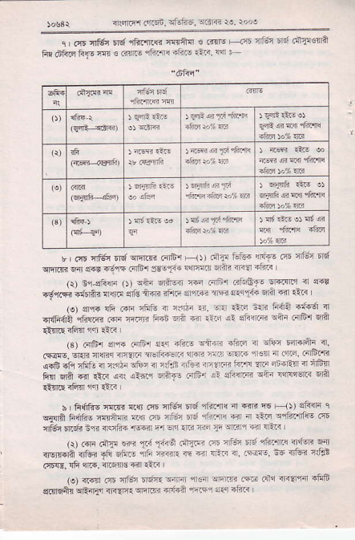
_{irr4lrfl d.on,} qfuftE. ^{qtR} ie. rooq
c m flftc Ed 1ftfts ${ih € .irlE +.qE nltrt td .+$!'lA fi! dFzr firs flr { .i@ lFm{ <fiF €3. {4 t
_{r | (rE} ^{q6n} n*qflm.irDr ^{F} _{1)) rnE 664} {rnf! aE nfit4 6ld _{r{mn} ^{qir} _{e1! .r.,'$ fi61e!-Ti.llli{ff} Frnr n'.? FfTn I rrr ,- eFiF (5) 'F _{drrq} ^{'E} a't' 6ir8f, t .4 tr { f{! +dn {3 'l!r?i r 4tr c'q rim it'T. _{a} .@ ld ^{s'} _{T& 6d} ^{rF!]} {tr{ /e) sP|{ {& .{F rF6 _{{ ntdd rr.} ^{qq} ilrn !.l. ffi? }n 6 { _{d(F6ii} qfrRi? ^{(!r"} rr.T,i _{F.aE} ^{qa} {ir €!r aa sftlnrB oiii _{c{F.l} q6
.sr c-Er 5F _{@rii'r} 6@ a @ dcaFl" a. m _{snn} :nn. _{r.s:al.riwrlfr?:.'} ^{''31gl} {.1.q'!:''iF _{i.fr 6fq a$z} ^{q} ?16 mr 4r {F-, @. ^{r} _{YrF'} r.r! eri 44 m r ffi'r fin €{A 6| A? _{oit} ^{qtflr.+F} .{tu E? _{sFnni} ^{qtu} rar1qqrr.i'n
h | _{fr6h€} ^{'nm} rq m nFa n6lGr.n{ n 4R F Fit _{al3lli} q ri4ff F{fts irr*aB lla m acn _{fl6} ^{'ifrft @} _{"r r.F} ^{qctuTlis} .qt
4Er Er6. 3q? irsifi4 ie@ Fr o5i rri ^{ffi} _{it} ^{qr4lq} 64 {E < i _{, I I .{F ctrr'} <€ _{fi $dt} ^{('r{'.?} ₋ 4!' D , _{"ftFnt} 1ldr6i @ *** <rrua +i" n"o r reft @ ?a Im {. (Ed,. 6} nlr;:+-i .qFd. !& ^{qr6.} Tr6r1ft 6r llii
_{.e\ c4n} ^{('E} n6 _{*i'{.} ^{q{nir qt€a qrf,rrl|a} _{.r@ atu} nF{'fl aiiF s(,ldftn cEari'r _{<rill'E} ^{qtro?} fli+A {'_iqe a€ rfitr
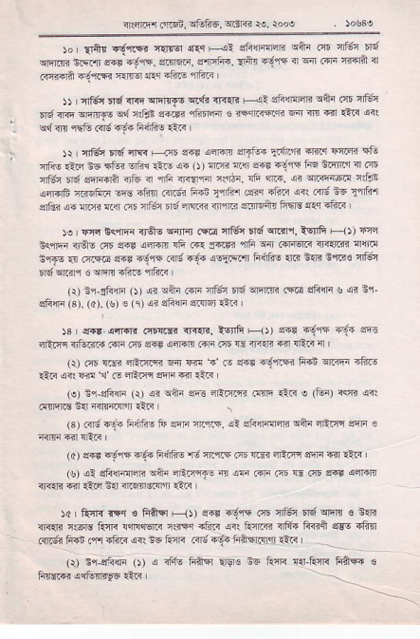
qlrlEi! ^{({Ei,} cfsfre, Rn€ )e. rod
)a I r1ftr .6-,r.rt _{t{rEi s€ Fli} qfr{FnFri ^{qdn} m 'tfti dq ^{q{Eri} sRn _{.?5 ad, r. s.irdi',} ^{q'Fh{.} _{Eitu} -djr5 a w .sra nT{l? 3 cqi4ra f63n {.lnq ir{.r !tud5 4f..< |
)) | ^{ql6r} _{'I{ rTr!} ^{qrflr{s} cif{ rF{. F!: _{si{la<ri} qilr (it trffi _{dq @ er-iirF} ^{q{} llB? er4inj riiErfl ! F rr.trn _{w {,r {.r.}.{} qrl ^{q{} _{n{} ^{qdn} .<16 -f{ F6frs {.< |
)r fl6rEdiF€ !r{ {crsnl sFtu€ _{!r4?-"r.ri.'r w.rj} qtr rfis iailr !6 *Gi oftl _{rts} ^{.4{} _{O)} :m {q d6t 4-e:qt ftq ifirn n .?E 'lfi# n6 sn{.ra irtu ? {6 _{aqrir} ^{q.dF.} !e fti. ,rr wnF@.! nlqt {drd6 a?61ia lrE.fii{ {.m-6? ^{Frn} _{flri?r} .!ir +1i?< '{rr.id ^{io} flli'r _{sdk} ^{q.} fllfr I14 i?r 46i nd rrfl< rrlqm ernM+n _{FErc} ^{q{q} -6.< |
ie |!'F _{b<,lfn <r&6} ^{q{Jrir} .rE n6 6ld $.ir, i6tfi F--{t 4!s lqlri ird- rnr e1'! acFF !fi Fr s4rFn _{rfi sn FF6rr{} ^{q,"4ra} {{fic l"ra6 .r @ElE s'r, djft .{d r.6? !!!!ql"l] F(ftr6 {a tq? cff€ nI64 _{rd} ^{ql.flq} € ^{qrqn} _{rfttg} .ftuti
(r) ^{nr-sFn} _{O) ai} ^{qan} .{F nfit? _{dq} qFl.n (ta _{shiF s} ^{qi Bq} sFffi _{c).} (c). (s) € ( ^{q)} <i sft{ln s.rdr tii-{ i
)s _{I sr.} ^{q.l.lir} .Jnir$ i]rtK. lE f6 F-rJ) @t .d:t{ q{ aR ^{qfr.i.} {,tunr4 .4r. .?r _{s1.} ^{q} _{.re c4n oi5 w rti4i} rFir lRrs 4 r (r) rct cE! ra{Filt 6-i @ _{ F er6n rdjiiR Fin wiFn Ffn 6 qati <r1 m { .o cRriq s!r{ e €.i
(o) n'i sturi (r) _{!r} ^{qn"} eft dE:nri .4nE Ett" e _{(fui) 3ffi} qir .lmlrc 3{ 4.rr41'B ?ii{ |
(3) Gr6 _{r'1? ftifi! ii atrn nEft5-} ^{ql} _{stura{cn} qai ^{.trt} rq srt € (dl ^{${r} _{"vff 4 lidEs} ^{'l;} _{{.,fi5 m ffi?} ^{:rEirr} enr T$ <rr ,
(s) _{at} qF{F:m ^{qnn} nriirnF _{n} ^{qF} r?ri .n5 Ti .?E ar{ aqriltl nrni a ilF 6{ {r@rs.{a €n
)4 | RrR rrq € F+!r F{t er{F €s3r nE nEc _{r{} ^{qim} € O{i srdr c:cE R{r< r4rrEn< i${{ _{rti.i} ^{qrt} turd rni? ft<ft s!-s 4ftn c{dtr 6l4n .qr _{4ft<} ^{qrr} be RqR ff6;{ifinrnlrs3L< | a _{tJ} ^{oijrnnr} _{ot} d _{rfrq Fh} qrvl€ i6
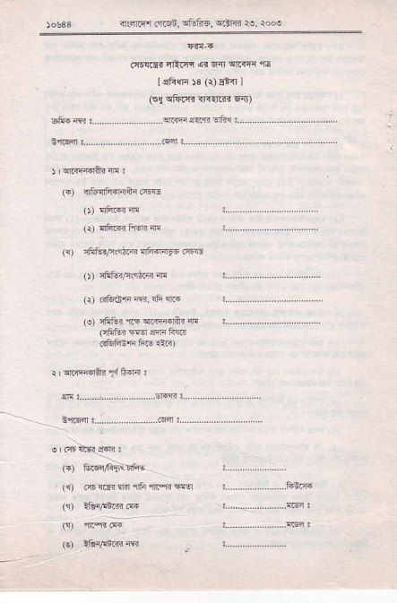
tasss _{<rrirt'i atsn,} ^{q6fiq..(ir{c} te. roos
_{fit{rlr rFt({.} ^{ql} _{6it} ^{qtiF} 1E
. IsFfi ^{l3} _{ir) E} itl
(!l cf4rTt xqd.tri FiI)
dto fr '.................
(") {itulfffiErn .!w
(r) {66fffin
({) _{nFtorFrqt@} ^{qftfdF6} tffi
o)
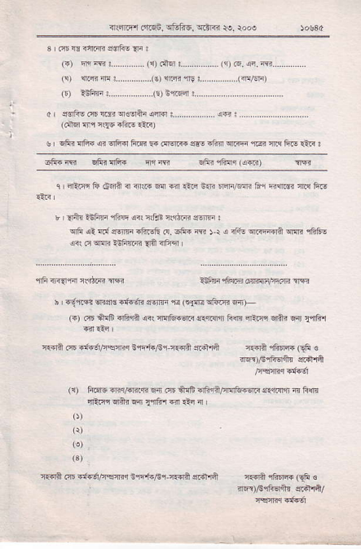
^{q..im} rjl.6i. a1,tu6. T.tri re. rooe
_{1s)} wn :..............(s) wa9
0 sri! _{sry} 3 r$r4r.
(dir4 4r ^{nq€ ltr} :iG)
s' sfir {Fr.4 olird tuR @ ffi e!: a6i !ffi ffi tu ft-.:rr: ^{-fr.} f, btu ^{4F.} _{"-€} ^{bnr"u.} r'n'
c 4Er4 tu _{6on} a d@ s a _{+F} E@ m/.m fr ']ffi @ FiE
r ^{i} lnx i6im r6q ar' .rfr n$tn ffi !
^{qt'} oa ai ^{!'W} _{"Feli} d. o,F! G 5 r i _{dn} ^{qffiiii} ffi rffis !1 _{o} ]@ -ift@ _{{i} Tifrq
l-tui,6,iF ffi,\i@ rr
^{r '} _{"d.m?} ^{ss!} _{"{fJF} $s,F r _{(nre !6.n} qF
_{@ 6 iFE {6tn} ^{qsr} _{ft6ffi} ^{qffit} _{lin} ^{qFiq qft4 w} r{6!
-aarit m d{6/'€mr i@i"Fq ?@n ^{affi ein lFEm} _{ei} c rR)r€rftdi! 4a1A
/FsRr{nfGi
({) 14@ *4,614€ w ft 5nE o,:lit5r$tu€F lrffi & 6n aftnqai@fljaRlnii'
cei @ r@i/qftr ir'+./6r-4.dn @Fffi &aA ^{ffiqe} _{Gn} € _{"dr E-'id5r} -r€l
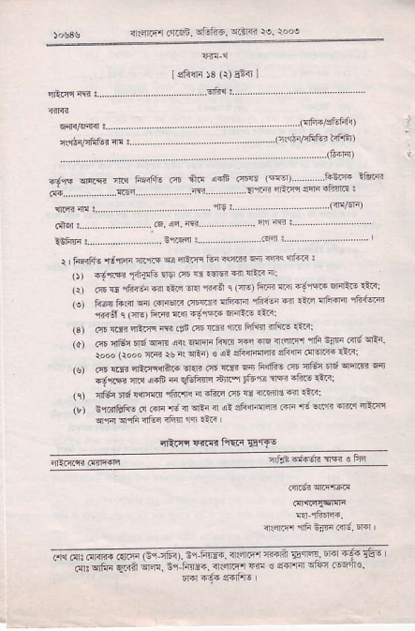
_{n:.n:;, trn,n+.rn,i.tr41} -'. ^.t
46f llrF ai isqfi. @ +.i ir'fi ffi _{lffir..} . . 1i3'& nFi F'''..'''. '',,'''.@','' '''. ,,''',-tr'. _{,'' ''' ?lfiq.4r} m.niE: .......... .... ..... f9:...... ..... .... .. . (dFrn)
r I ii{if€ +N _{41F} ^{q q.F} i.n
_{o)} ^{+1@i} _{Ticrfs} ^{qru,} mE1@frqaFi:
_{G)} 6 ft +inn d aF @ iriii c _{lE)} i@ T,i a:.!lw @inF r'F: rli l@ Ed n _{@itu]F} (m _{rrf{fi iFriF} q.!- ^{q6fr 1ftitr} ' ' fiDl l _{lft) i@ {4;".} nF .i- ea€: @ d aFrF _{ffi} ^{(!n} m dF m 6nm iF^ !iF:
@ ']€i FEi w {1ffi f@ ft @ iqd 1F _{tiF rit} q _{rooo} (rooo _{@ rs nt} ^{q-)} € c? eft@4 eirF ffi .lza: _{ft @qt-f53 dsr F} -4, ₄ ^{r+'} I a+ F a1@ m{ 3uii ^{F} _{lftilm fiF rftE} rfi m '_n
if"'r tF _{r!ffi c6fr1 i} ^{qton} ft
nr..i1Ef€ o .4F _{d {} ^{qEi} { {t 3fr4mh _{dF'E -.t} :Rc qiTr ^{qfl q16} 4i-q iifl il! .-F
^{qftnt F4n f"n6} S'!6E
a; trr dffi ar's (s+lr"-,r" !4iaF. rrrqr z4 4 _{Eqr4.} ffi ri. Ift-o _{.sr} qr{Ti q]nir rm. ir.tuF. i

